Download and unzip kernel:
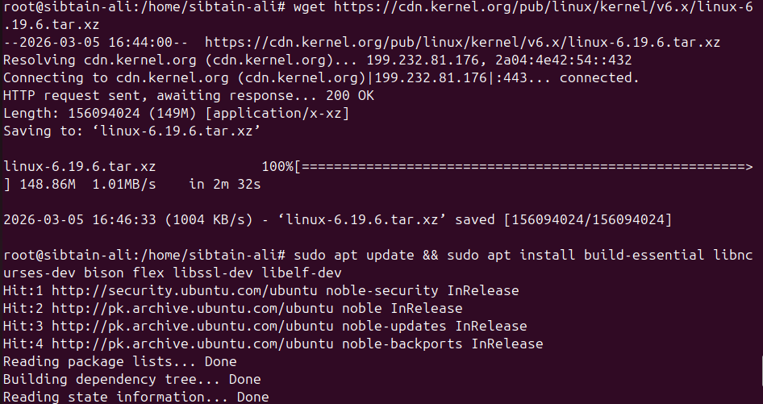

Create and Register the system call: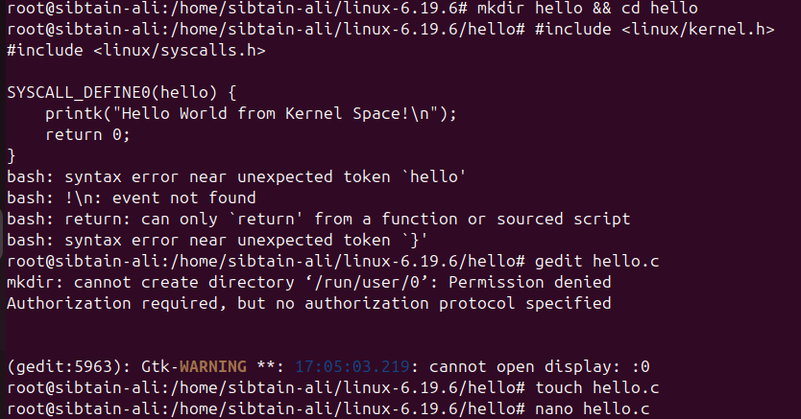
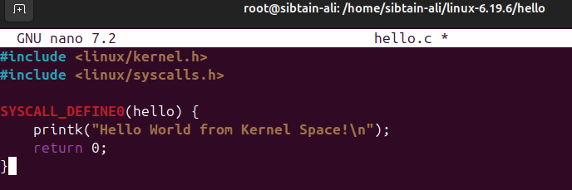
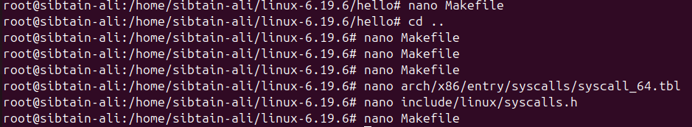
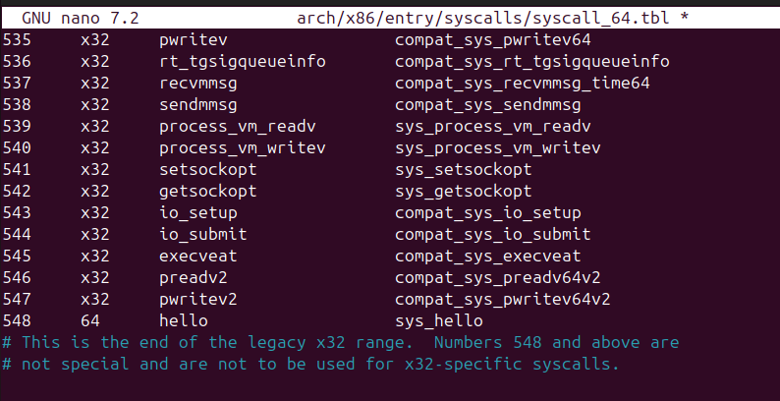
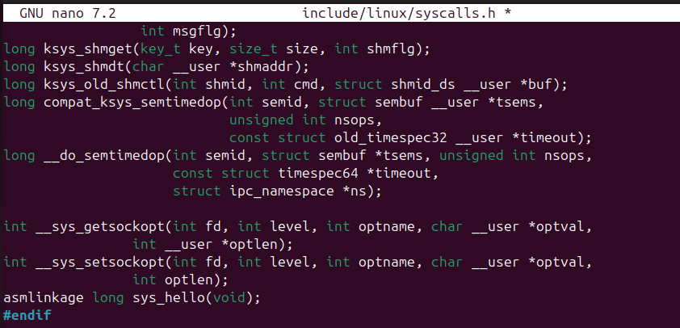

Name and Configure Kernel:
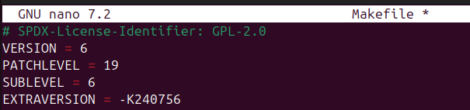
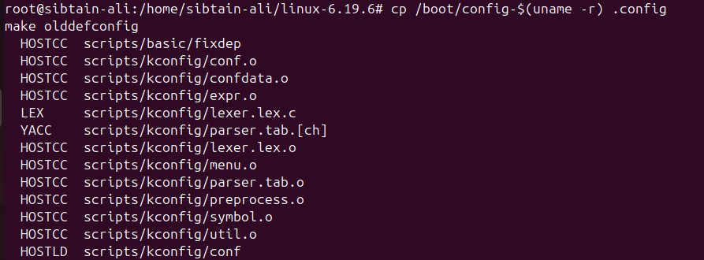

Building the Kernel:
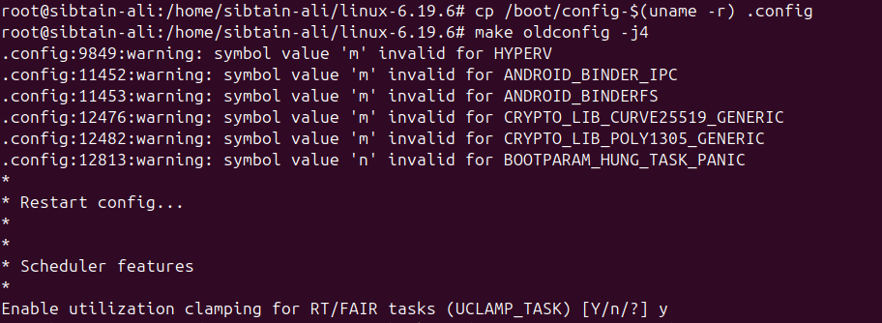
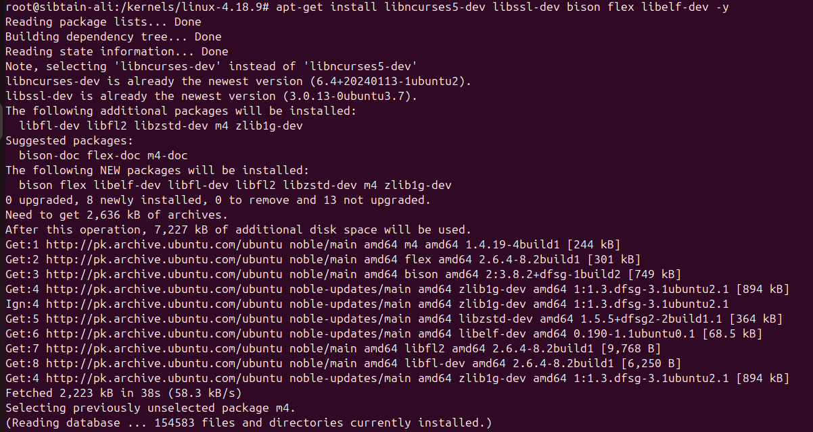
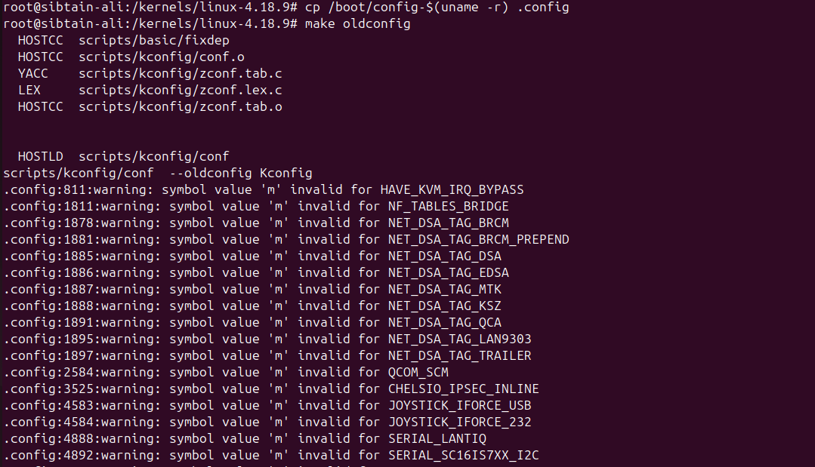
Recurring error @ 3rd command of “make bzimage” in Kernel:

SCREENSHOT FOR EVERY STEP NOT POSSIBLE DUE TO RECURRING ERRORS AND LAGGING

